**User Manual**

1. **Open the application (adib.exe)**
2. **enter the simulation Number (must be an integer)**
3. **enter the seed number (must be an integer)**
4. **click on the submit button.**
5. **Show the simulation results**
6. **Clows the window**

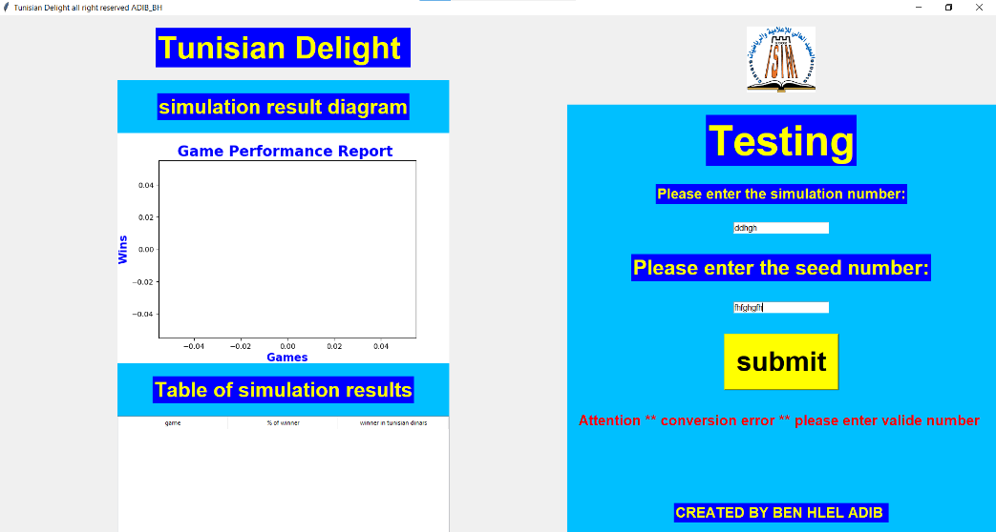

**PS:**

**- An error message if you enter an invalid Type: “Attention ** conversion error ** please enter valid number. "**

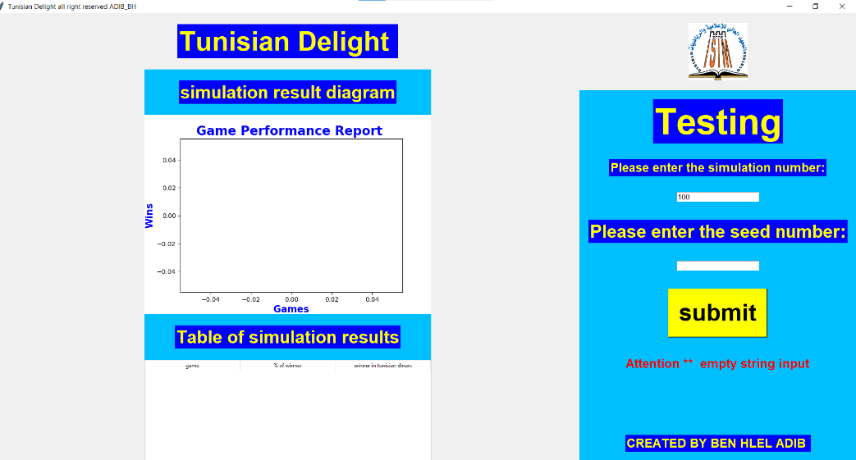

**-An error message if you don’t enter a value: “Attention ** empty string input. "**

**-the testing was done in the function go**